AWN
ORPHANS ORGANIZATION

PREPARED BY SAHBY GROUB:
- YASMIN ESSAM
- SALMA BAHAA
- HABIBA AHMED
- AYA MOHAMMED
- HABIBA MAHMOUD
- BOSINA SAAD

SUPERVISOR
Dr. Yaser Abdalla

Table of Contents
Introduction 4
Scope Management Approach 5
Roles and Responsibilities 5
Scope Definition 7
Project Scope Statement 7
Work Breakdown Structure 8
Scope Verification 9
Scope Control 10
Sponsor Acceptance 11

Introduction
In our project area number of Orphan, Semi Orphan and Street Children are found. The problem of orphan / street children is acute due to urbanization and industrialization. Due to the deaths of HIV/AIDS affected persons, Re-marriage of deserted / widowed / divorce women, absence of love and security in the families, Family disputes, Unwanted pregnancy of Trafficking / Sexually exploited girls; these orphans and street children are left without care and support. These children are involved in rag picking, pick pocketing and participating in anti-social, criminal activities.
Therefore, we envisage mainstreaming these children in the national building by providing care, support and protection in our ORPHAN CHILDREN HOME.

SUMMARY

This orphanage home aims to provide care, support and protection for 60 orphan & street
children. This home has 3 Care Takers, One Teacher, One Vocational instructor, one cook, one
attendant, one watchman. A doctor is conducting health check-up & providing medicines. All the inmates are being provided with 3 time’s nutritious food, one set of books and 4 sets of uniforms and regular dresses. Every child has opportunity for indoor and out-door recreation and play facilities along with training in crafts and hobbies

Roles and Responsibilities
The problem of orphans/ street children is acute due to urbanization and industrialization. Recent floods in our area aggravated the situation further. Due to the Deaths of AIDS affected persons, Re-marriage of Widowed/ Divorce women, Absence of love and security, Unwanted pregnancy of Sexually exploited girls; these orphan & street children are left without care and support.
These children are involved in rag picking; pick pocketing & participating in anti-social, criminal
activities.

The Project Manager, Sponsor and team will all play key roles in managing the scope of this project. As such, the project sponsor, manager, and team members must be aware of their responsibilities in order to ensure that work performed on the project is within the established scope throughout the entire duration of the project. The table below defines the roles and responsibilities for the scope management of this project.

Name | Role |  | Responsibilities
John Doe | Sponsor |  | - Approve or deny scope change requests as appropriate  - Evaluate need for scope change requests  - Accept project deliverables
Habiba Mahmoud | Team Lead |  | - Measure and verify project scope  - Validate scope change requests  - Participate in impact assessments of scope change requests  - Communicate outcomes of scope change requests to team  - Facilitate team level change review process  - Responsible for Licenses.  - Contribute to Budget Stage by recruiting workers.  - Contribute to Marketing Stage through social media.
Bosina Saad | Team Member |  | - Contribute to Budget Stage through sets the resources budget.  - Handle well decisions.
Yasmin Essam | Team Member |  | - Contribute to Budget Stage through sets Health care budget.  - Contribute to Marketing Stage to sponsors.
Salma Bahaa | Team Member |  | - Contribute to Budget Stage through setting the furniture budget.  - Contribute to Marketing Stage through making advertisements.
Habiba Ahmed |  | Team Member |  | - Contribute to Budget Stage through sets the Education budget  - Contribute to Implementation Stage through place preparation.
Aya Mohammed |  | Team Member |  | - Do Search Stage about: place, volunteers, sponsors and workers.  - Contribute to implementation stage through doing interviews for workers and sets sponsors which will deal with.
Table 1.1, Scope Management Roles and Responsibilities

Scope Definition
The problem of orphans/ street children is acute due to urbanization and industrialization. Recent floods in our area aggravated the situation further. Due to the Deaths of AIDS affected persons, Re-marriage of Widowed/ Divorce women, Absence of love and security, Unwanted pregnancy of Sexually exploited girls; these orphan & street children are left without care and support.
These children are involved in rag picking; pick pocketing & participating in anti-social, criminal
Activities.

How will this project solve this problem?

We have been identifying orphans & street children, pre-viewing, counseling & providing
Lodging and boarding facilities for all inmates. We are arranging teaching facilities in nearby
schools & providing home tuitions, health check-up, medicines, cosmetics, one set of books &
2sets of uniform every year. This proposal covers 50 orphans & street children. Every child is
being provided with nutritional diet, indoor & outdoor recreation and play facilities and training in crafts and hobbies

Project Objectives:
- To provide orphan / semi orphan / street children, a childhood that they never
- experienced and help them to become useful members of society.
- To encourage orphan / semi orphan / street children to kindle their potential by providing
- creative opportunities
- To make available a secure place where orphan / semi orphan / street children can play
- and enjoy their childhood.
- To provide basic education to orphans / semi orphans / street children.
- To provide such welfare services like free lodging, boarding, health and recreation
- To provide basic literacy and facilities for those who wish to study further
- To select and prepare for a vocation in order to live on their own legs
- To accomplishing physical, intellectual and aesthetic development of the child

The project scope statement provides a detailed description of the project, deliverables, constraints, exclusions, assumptions, and acceptance criteria. Additionally, the scope statement includes what work should not be performed in order to eliminate any implied but unnecessary work which falls outside the of the project’s scope.

This project includes the design, programming, and testing of a new software application for tracking the company’s finances. The deliverables for this project are a completed software application for finance tracking with the flexibility to modify and expand the application as necessary in the future. This project will be accepted once the new software has been successfully tested in each department and has been shown to be compatible with the company’s current information technology (IT) infrastructure. This project does not include ongoing operations and maintenance of the software. Only internal personnel and resources may be used for this project. Additionally, the project is not to exceed 465 days in duration or 1674700.00EG in spending. Assumptions for this project are that support will be provided by the project sponsor and all department managers and that adequate internal resources are available for the successful completion of this project.

Work Breakdown Structure
The Work Breakdown Structure (WBS) and Work Breakdown Structure Dictionary are key elements to effective scope management. This section should discuss how the project scope is to be subdivided into smaller deliverables in the WBS and WBS Dictionary and how these smaller components are managed during the life of the project.

In order to effectively manage the work required to complete this project, it will be subdivided into individual work packages which will not exceed 40 hours of work. This will allow the Project Manager to more effectively manage the project’s scope as the project team works on the tasks necessary for project completion. The project is broken down into three phases: the design phase; the programming phase; and the testing phase. Each of these phases is then subdivided further down to work packages which will require no more than 40 hours of work and no less than 4 hours of work (see WBS structure below).

Figure 1.1, Work Breakdown Structure (WBS)
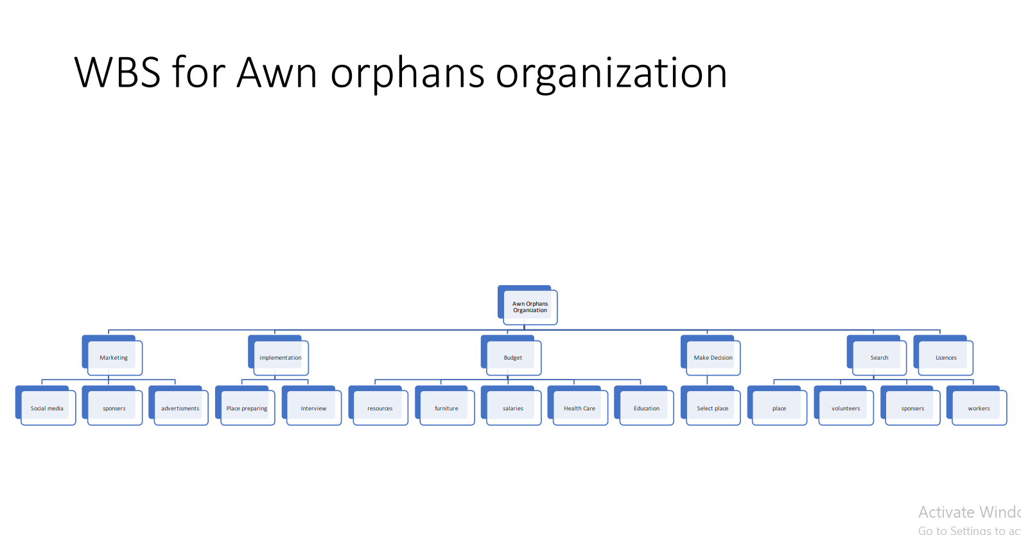

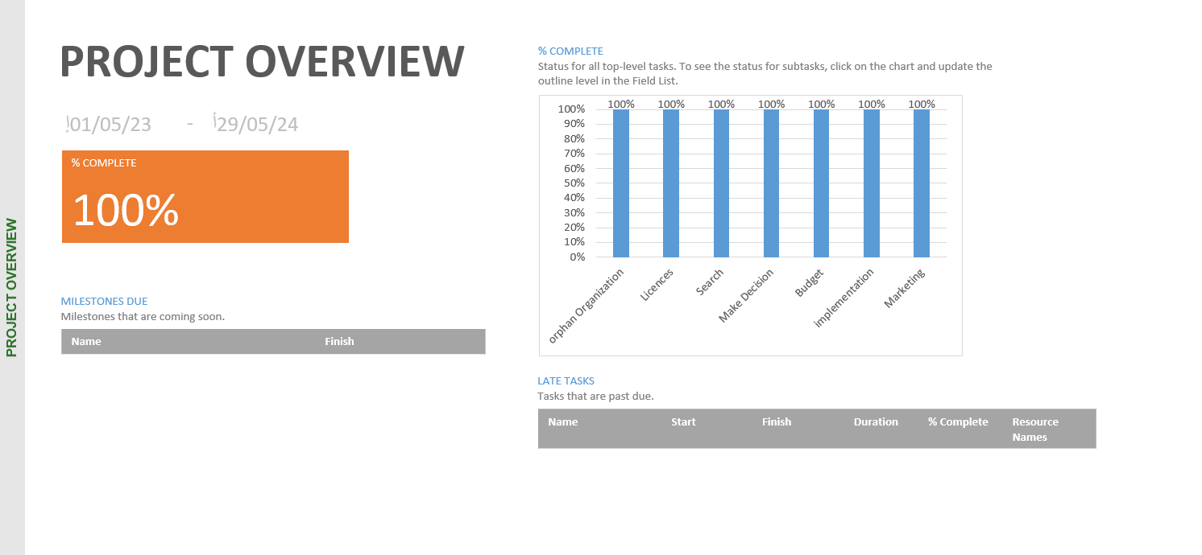
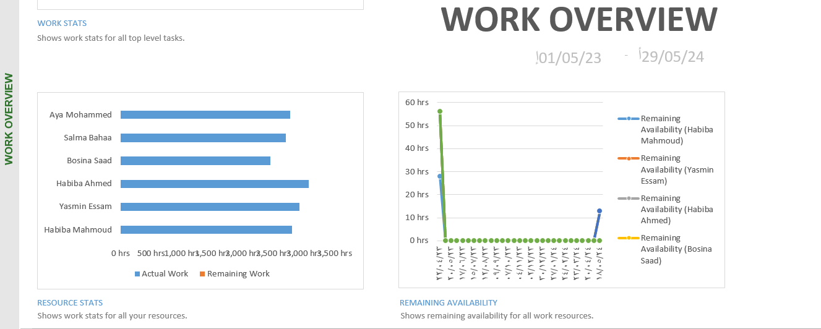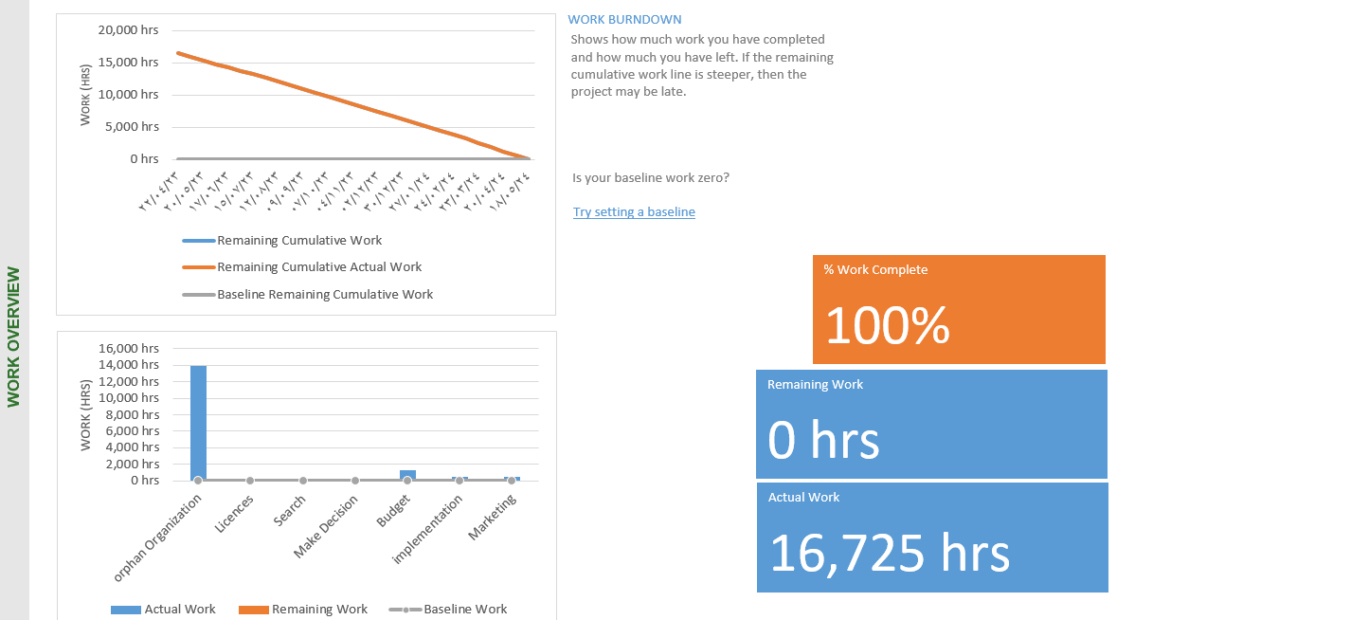

Scope Verification:

- Identification of orphan / semi orphan / street children
- Pre-view of the incoming orphan / semi orphan / street children's problem/difficulties
- Emotional acceptance of the child
- Teaching facilities for basic education
- Teaching facilities for vocational courses and crafts.
- Lodging and boarding facilities for all inmates.
- Recreational facilities.
- Primary health.

Scope Control
Methodology:
We have been identifying orphan / semi orphan / street children through our volunteers, citizens, police, women & child welfare department. We Pre-view of the incoming orphan / semi orphan / street child problems/difficulties. We counsel and arrange for Emotional acceptance of the orphan / semi orphan / street child. We provide Lodging and boarding facilities for all inmates at a rented building in Budhawarpet of Kurnool city. We arranged teaching facilities in nearby schools according to their age. We also provide home tuition, recreation and health care.

We have been running the Orphanage with local donations and contributions only. We
mobilizing both cash and kind. We have limited resources to take care of about 50 orphan / semi orphan / street children. But, day by day number of children are increasing due to various
reasons. We need additional support from the donors and philanthropists to meet the needs of
increasing orphan / semi orphan / street children in our center. We seek support for about 3
years. Meanwhile, we will sustain to mobilize continuous local donations through exhibiting our good work and service. We are planning to build permanent home by acquiring land from the
donors and philanthropists.

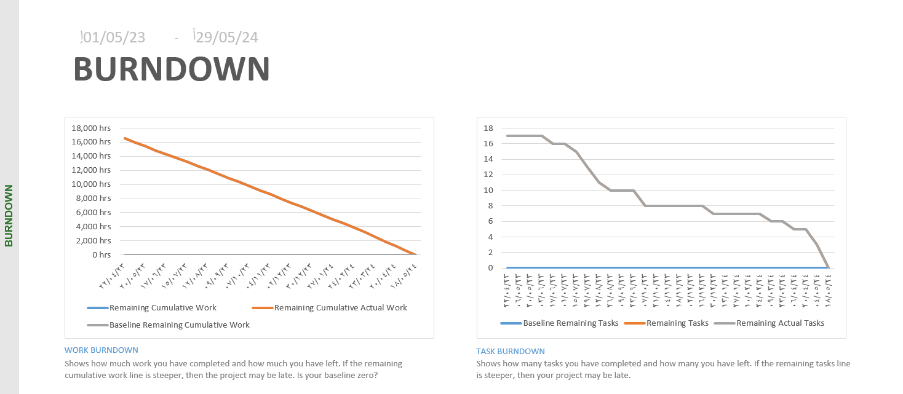
This home will have one Caretaker who besides handling day-to-day administration and will
look after the hostel as warden. One Teacher, One vocational instructor, One cook, One
attendant, One Watchman will be provided for the home. A doctor will be appointed as Center
Medical Attendant on honorarium and all the inmates will be provided with health check-up,
medicines, food, cosmetics, one set of books and two sets of uniform every year.
The proposal covers 60 orphans. Every child will be provided with nutritional diet, indoor and
out-door recreation and play facilities and training in crafts and hobbies.

COST OVERVIEW:
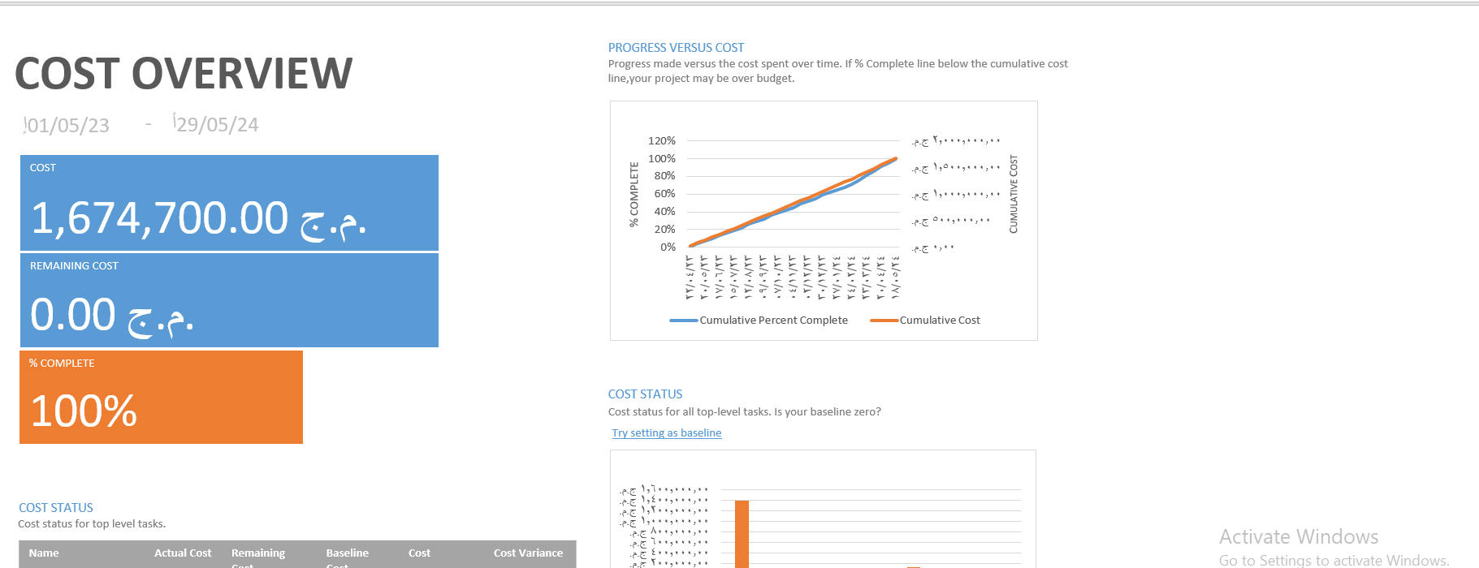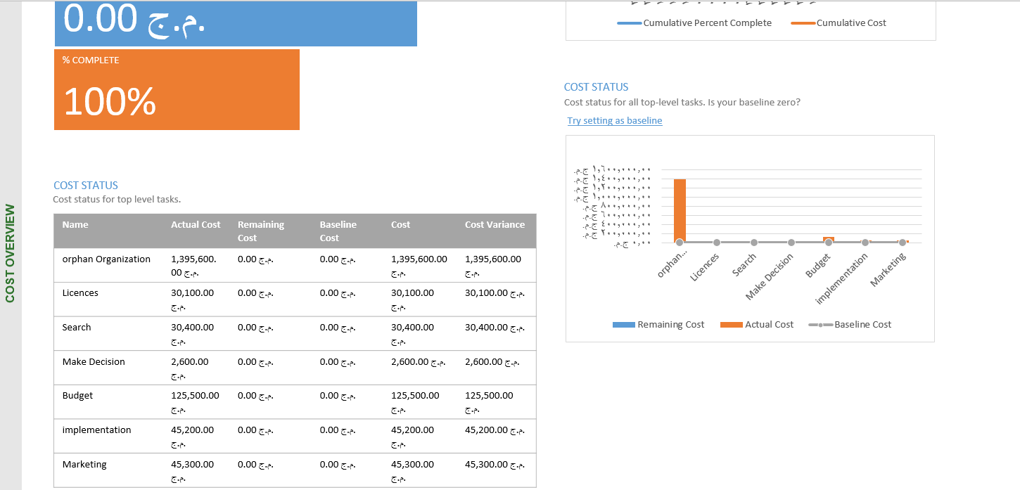

Sponsor Acceptance

Approved by the Project Sponsor:

Date:
<Project Sponsor>
<Project Sponsor Title>

This free Project Scope Management Plan Template is brought to you by www.ProjectManagementDocs.com

